
Habib University
School of Science & Engineering
Student Name & ID
Course: | EE – 211 – Basic Electronics
Semester | Fall 2024
Quiz # | 3
Date : | April 05, 2024
Instructor : | Syed Arsalan Jawed
Total Marks : | 10
Instructions for Students
- Provide your answer within the empty spaces given after each question.
- Keep your answers concise and to the point. Provide neat and tidy calculations and plots.
- Make reasonable assumptions motivated by your class lecture notes.

Question # 1 : CLO-1 [5]
Consider the following schematic that shows an NPN BJT configured to operate in a certain region.
- Identify the region. List down the expressions for emitter, base and collector currents and current gains.
- Inspired by the depiction, similarly depict the current flows in the operational region where both junctions are forward biased. Identify the region also.
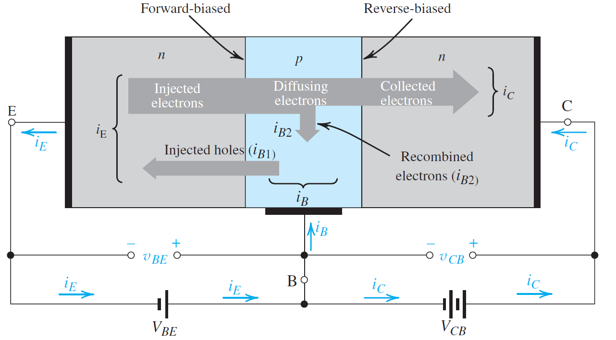

Question # 2 : CLO-2, CLO-3 [5]
Find I_{C}, I_{B}, I_{E}, V_{B}, V_{C} and V_{E} for the following circuits. Assume β=100.

